Smart Parking Platform
Software Requirements Specification
WE ARE $oftware ¢orp
Jahshua Grant

Project Overview:
- WE ARE $oftware ¢orp. is a made-up software company for this project, and for the sake of the assignment we're pretending we have unlimited time and budget. A city's transportation department reached out to us because parking downtown was a mess: drivers were wasting time driving around looking for a spot, and the people running the parking garages didn't really have any good tools to see how full their garages were or manage pricing. So we pitched the Smart Parking Platform — an app and website where drivers can find, reserve, and pay for parking in real time, plus a dashboard so garage operators can actually manage their space.
Goals:
- Cut down the average time it takes a driver to find and park by 30% in the first two months after launch.
- Get reservations to actually work 95%+ of the time — meaning the spot is really open and the access code works when the driver shows up.
- Get at least 10 parking garages/lots signed up for the first city rollout.
- Help operators who use our dashboard and pricing tools increase how full their garages get on average by 15%.
Research:
Competitor | Strengths | Weaknesses
SpotHero | Biggest app for booking garage/lot spots ahead of time in North America, with over 7,000 locations, and you usually save around 30% compared to just driving up and paying. | Built for booking ahead, not last-minute parking. People complain the price goes up between when they search and when they check out, and sometimes the access code doesn't work at the gate.
ParkMobile | Has 1.5M+ spots on-street metered parking and is the official meter-payment app in a lot of cities. | The "convenience fee" is a big markup on cheap meters, and some users say they got charged for parking sessions they never actually started. Not much for garage reservations.
ParkWhiz | Good for booking garage/lot spots near venues and airports, with discounts up to 50% and an easy booking flow. | Doesn't have as many locations as SpotHero, and sometimes garages don't recognize the reservation when you actually show up. Refunds can take 10-15 business days.
PayByPhone | The official app cities use for paying at parking meters. | Alerts that your time is running out sometimes show up late, and the app has gone down during busy hours, so people couldn't pay at all.
Passport Parking | Used a lot for city parking and college campus permits. | The app crashes during payment, the zone numbers don't always match the signs, and customer support just bounces you between the app and the city.

What makes us different:
- Combine street parking and garage reservations into one app instead of making people juggle two or three different ones.
- Keep the app and the actual gate in sync so reservations and access codes just work, since this is a common complaint with SpotHero and ParkWhiz.
- Lock in the price when someone books, so it doesn't jump up at checkout like people complain about with other apps.
- Give garage operators real tools (occupancy stats, pricing controls, reports), since none of the apps we looked at really do that.
- Let drivers report a problem straight to the operator in the app, instead of getting stuck in a support loop like with Passport Parking.

1. Introduction
1.1 Purpose
This document lays out what the Smart Parking Platform needs to do. It’s here to guide how we design, build, and test the app.
1.2 Scope
In-Scope
Signing up and logging in
- Seeing real-time parking availability on a map
- Reserving a spot and paying for it in the app
- Reservation history, receipts, and notifications
- A dashboard for operators to manage pricing and see occupancy reports
- Hooking into outside mapping/navigation apps

Out-of-Scope
- Building or installing parking gates or sensors
- Self-driving or robotic parking/retrieval systems
- EV charging management inside the app
- Supporting cities outside the one we're piloting in
2. Overall Description
2.1 Users
- Drivers / vehicle owners
- Parking garage/lot operators
- System administrators
- Finance and billing staff
- Outside payment and mapping/navigation services (not human users, but the app talks to them)
2.2 System Environment
The platform is an iOS app, an Android app, and a website that all talk to the same cloud backend. Operators get their own dashboard through the website. The app connects to outside mapping/navigation services and payment processors, and to each garage's occupancy sensors or ticketing system when they have one.
2.3 Constraints
- We're assuming an unlimited budget for this project (it's fictional, so why not)
- A fixed semester-length timeline
- We're relying on outside services and APIs for things like maps and payments
- Has to follow security/privacy rules and city parking laws
2.4 Assumptions
- Garages we work with can give us a live feed of how full they are, through an API.
- There's a payment processor available that handles the security/compliance side of taking payments.
- There's a mapping/navigation service available for showing maps and giving directions.
- The city will give us the parking rules and zone info we need.
Use Cases:
- Finding a Parking Spot
Commuter: A commuter wants to find an open parking spot near their office before they even leave the house. They open the app, type in where they're headed, and the app shows them real-time open spots on a map so they can pick one before driving over.
Precondition: User is logged in and either has location on or types in a destination.
Steps:
- Users enter a destination or uses their current location.
- System checks nearby garages for real-time open spots.
- System shows a list and map of open spots with price and distance.
- User picks a spot and moves on to booking it.
- Creating an Account
New User: A new driver downloads the app and wants to sign up so they can start reserving and paying for parking. They sign up with an email, verify it, and they're logged in right away.
Precondition: User doesn't have an account yet.
Steps:
- User taps "Create Account" and enter their name, email/phone, and a password.
- System checks that email/phone isn't already used.
- System sends a verification code.
- Users enter the code and their account is set up.
- Logging In
Returning User: A returning driver opens the app and logs in with their saved login info so they can get to their reservations and payment methods.
Precondition: User already has a verified account.
Steps:
- Users enter their email/phone and password (or uses Face ID/fingerprint).
- System checks that the login info is correct.
- User is logged in and taken to the home screen.
- Reserving a Parking Space
Commuter: After finding a spot, a driver wants to lock it in before somebody else grabs it. They pick their arrival time, pay ahead of time, and get a digital pass to get in.
Precondition: User picked a garage/lot with open spots and is logged in.
Steps:
- User picks an arrival and departure time for the spot.
- System double-checks the spot is still open and shows the total price.
- User confirms and pays with a saved card.
- System sends a digital pass (QR code or access code) and saves the reservation to the user's account.
- Cancelling a Reservation
Commuter: A driver's plans change and they don't need their spot anymore, so they cancel it and expect a refund if it's still within the cancellation window.
Precondition: User has an upcoming reservation that hasn't started yet.
Steps:
- User goes to "My Reservations" and picks the one to cancel.
- System shows the cancellation policy and how much of a refund (if any) they'll get.
- User confirms the cancellation.
- System frees up the spot, updates the reservation status, and processes the refund if there is one.
- Paying for Parking
Commuter: A driver pays for a reservation or a walk-up session right in the app with a saved card, so they don't need cash or a ticket machine.
Precondition: User has a card saved, or adds one at checkout.
Steps:
- User confirms how much they owe at checkout.
- System sends the charge to the payment processor.
- Payment processor approves the charge.
- System saves the transaction and creates a receipt.
- Viewing Reservation History and Receipts
Frequent User: A driver who parks a lot wants to look back at past reservations and grab receipts, maybe to get reimbursed for work.
Precondition: User is logged in and has at least one past reservation.
Steps:
- User opens "History" from their account menu.
- System shows past and upcoming reservations with their status.
- User picks one to view or download the receipt.
- Receiving Notifications
Commuter: A driver wants a heads-up when their reservation goes through, and another one shortly before it's about to run out, so they don't get hit with extra charges out of nowhere.
Precondition: User has notifications turned on and has a reservation.
Steps:
- Something notification-worthy happens (booking confirmed, time almost up, receipt ready).
- System sends a push notification, text, or email.
- User sees the notification and can tap it to go straight to the reservation.
- Navigating to a Facility
Commuter: Once a reservation is booked, a driver wants turn-by-turn directions straight there instead of having to pull up a different maps app themselves.
Precondition: User has a booked or selected garage/lot.
Steps:
- User taps "Navigate" from the reservation screen.
- System sends the location over to the driver's maps app.
- The maps app opens with directions to the entrance.
- Updating Profile and Payment Methods
Returning User: A driver gets a new card and needs to swap it in, and also wants to fix their vehicle info on file.
Precondition: User is logged in.
Steps:
- User goes to "Profile & Payment Settings."
- User edits their info or adds/removes a payment method.
- System checks everything looks right and saves the changes.
- Reporting an Issue at a Facility
Commuter: A driver shows up and finds someone else parked in their reserved spot, so they need to flag it so the operator can deal with it right away.
Precondition: User has a current or recent reservation at that garage/lot.
Steps:
- User taps "Report an Issue" from the reservation screen.
- User picks what kind of issue it is and adds a quick description.
- System sends the issue straight to the garage operator.
- System lets the user know it was received and roughly when to expect a response.
- Viewing the Occupancy Dashboard
Parking Operator: A garage operator wants to check in real time how full their garage is and how much money it's bringing in today.
Precondition: Admin is logged into the operator dashboard and manages at least one garage/lot.
Steps:
- Admin logs into the dashboard.
- System shows current occupancy, active reservations, and revenue for each garage/lot.
- Admin can filter by location, date range, or space type.
- Managing Pricing
Parking Operator: An operator wants to raise prices during a big event downtown and lower them on slow weekday afternoons, so they set that up themselves.
Precondition: Admin has permission to manage pricing for that garage/lot.
Steps:
- Admin opens "Pricing Management" for a garage/lot.
- Admin sets up a pricing rule (regular rate, time-based, or event pricing).
- System checks for conflicts with rules already in place.
- Admin publishes it and the new pricing shows up right away.
- Generating an Occupancy Report
Parking Operator: At the end of the month, an operator needs a report on occupancy and revenue to send to the city and their own finance team.
Precondition: Admin is logged in and there's data for the time period they want.
Steps:
- Admin picks a garage/lot, date range, and report type under "Reports."
- System pulls the historical data together and shows a preview.
- Admin downloads the report as a PDF or CSV.
- Administering the Platform
System Administrator: A system admin needs to add a new garage to the platform and make sure its data feed is hooked up right.
Precondition: Admin has admin-level access to the system.
Steps:
- Admin adds a new garage/lot with its location and how many spots it has.
- Admin connects that garage's occupancy feed or ticketing system.
- System checks the connection is working and starts showing the garage in search results.

Work Breakdown Structure (WBS)
- Authentication & Account Management
  - User Registration
    - Sign-up form (email/phone)
    - Email/SMS verification
    - Account activation
  - Login & Session Management
    - Login screen (password + biometric)
    - Session/token handling
    - Password reset flow
  - Profile & Payment Method Management
    - Edit profile and vehicle info
    - Add/remove payment methods
- Parking Search & Reservation
  - Real-Time Availability Search
    - Location input
    - 2.1.2 Occupancy data lookup
    - 2.1.3 Results list and interactive map
  - Reservation Booking
    - 2.2.1 Space and time selection
    - 2.2.2 Price confirmation
    - 2.2.3 Digital pass generation (QR/access code)
  - Reservation Management
    - Cancellation and refund handling
    - Reservation history and receipts
    - Notifications (confirmation, expiration alerts)
- Payments
  - Payment Processing
    - Payment provider integration
    - Charge authorization and capture
    - Receipt generation
  - Refunds
    - Refund policy logic
    - Refund processing
- Navigation & Mapping
  - Map Display
    - Interactive map rendering
    - Facility pins and details
  - Turn-by-Turn Navigation
    - Navigation provider integration
    - Hand-off to external maps app
- Reporting
  - Occupancy Reports
    - Historical data aggregation
    - Report generation (PDF/CSV)
  - Revenue Reports
    - Revenue aggregation by facility
    - Export and scheduling
  - Issue Reporting
    - In-app issue submission
    - Routing to operator
    - Response tracking

Gantt Chart 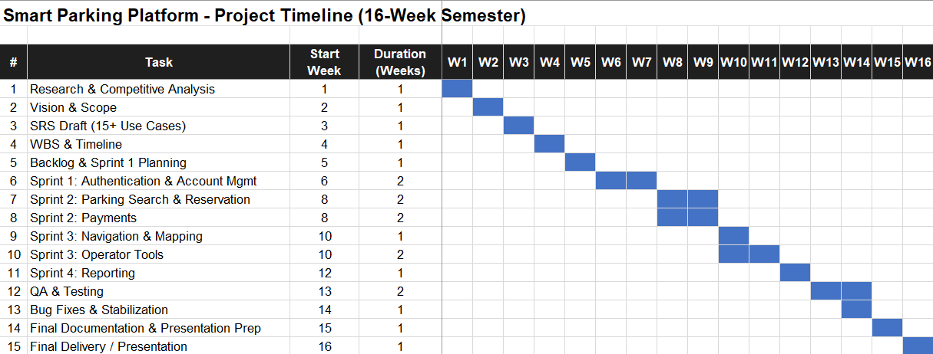

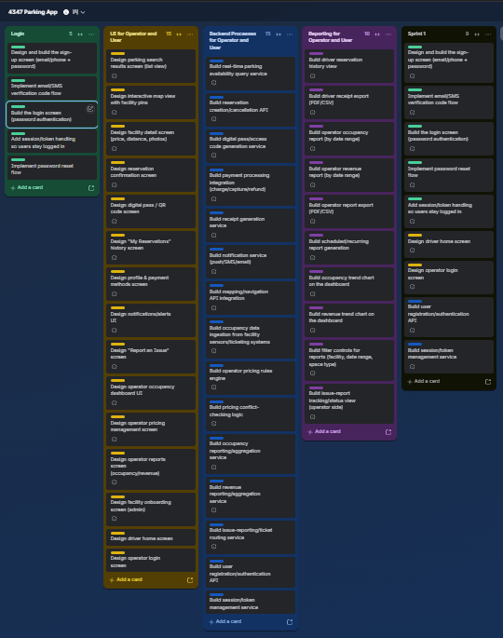

Risk Management
Technical Risks
- The app could have bugs when connecting to the parking sensors or the payment system, which could mess up a user's reservation.
- We're relying on a few different outside APIs (maps, payments, notifications), so if one of them changes or goes down, part of our app could stop working.
- We don't have a lot of experience building real-time features, so the live occupancy updates might be harder to get working smoothly than we think.
- Team members are building on different laptops and setups, so there's a chance of compatibility issues when we try to put all the code together.
Schedule Risks
- Since team members are staffed across multiple active client projects, we could fall behind if someone can't finish their part on time.
- Sprint 1 (login and authentication) could take longer than planned if those features turn out to be trickier than expected.
- We only have a fixed 16-week delivery window to get everything done, so any delay early on could push back testing and our final launch.
- Team members are also supporting other active engagements, which can make it hard to find overlapping time to work together.
Financial Risks
- Even with an unlimited project budget, vendor and API costs (like a real payment processor or a paid maps API) could scale faster than expected as usage grows, eating into margins once the product launches.
- We're using sandbox/trial tiers of some third-party tools during development, so if we hit usage or rate limits, service could be throttled until we upgrade to paid plans.
- Domain registration, hosting, and developer/app-store accounts needed to publish or demo the app are costs that need to be budgeted for even under an unlimited-resources assumption.
- We might underestimate the cost of tools we need later on, like paid design software or extra cloud storage, and have to scramble to procure it.
People Risks
- If a team member leaves the company or gets pulled onto another project, the rest of the team has to scramble to cover their part.
- Miscommunication between team members could cause two people to work on the same task or cause a task to get missed completely.
- Not everyone on the team has the same amount of coding experience, so some members might need more time to finish their assigned work.
- If someone gets sick or has a family emergency, we'd need to shift their responsibilities to someone else on short notice.

Risk Register
R1 – Parking reservation bugs
  - ID, Description: R1, Payment or sensor API bugs break a reservation
  - Probability, Impact: Medium, High
  - Owner, Response Strategy: Backend Lead, Test APIs early and build in error handling
  - Status/Notes: Open
R2 – Third-party API outage
  - ID, Description: R2, A 3rd-party API (maps/payments) goes down or changes
  - Probability, Impact: Low, High
  - Owner, Response Strategy: Backend Lead, Have a backup plan and monitor API status
  - Status/Notes: Open
R3 – Slow or laggy occupancy updates
  - ID, Description: R3, Real-time occupancy updates don't work smoothly
  - Probability, Impact: Medium, Medium
  - Owner, Response Strategy: Backend Lead, start with a simple version and improve it over time
  - Status/Notes: Open
R4 – Team falls behind schedule
  - ID, Description: R4, Team falls behind due to other active projects
  - Probability, Impact: High, Medium
  - Owner, Response Strategy: Project Manager, Build extra buffer time into the schedule
  - Status/Notes: Open
R5 – Sprint 1 takes longer than expected
  - ID, Description: R5, Sprint 1 takes longer than expected
  - Probability, Impact: Medium, Medium
  - Owner, Response Strategy: Scrum Master, Break tasks into smaller pieces and check in weekly
  - Status/Notes: Open
R6 – Timeline runs out
  - ID, Description: R6, Limited delivery timeline pushes back testing and launch
  - Probability, Impact: Medium, High
  - Owner, Response Strategy: Project Manager, Track progress against the Gantt chart every week
  - Status/Notes: Open
R7 – Vendor costs rise
  - ID, Description: R7, Vendor/API costs scale faster than expected as usage grows
  - Probability, Impact: Low, Medium
  - Owner, Response Strategy: Finance Lead, Negotiate vendor contracts early and monitor usage trends against cost projections
  - Status/Notes: Open
R8 – Vendor rate limits hit
  - ID, Description: R8, Vendor rate limits throttle service during peak usage
  - Probability, Impact: Low, Low
  - Owner, Response Strategy: Finance Lead, monitor usage and set alerts before limits are hit
  - Status/Notes: Open
R9 – Team member(s) leaves
  - ID, Description: R9, Team member(s) leaves the company or is reassigned
  - Probability, Impact: Low, High
  - Owner, Response Strategy: Project Manager, Crosstrain so more than one person knows each part
  - Status/Notes: Open
R10 – Team miscommunication
  - ID, Description: R10, Miscommunication causes duplicate or missed work
  - Probability, Impact: Medium, Medium
  - Owner, Response Strategy: Scrum Master, Use the Trello board and weekly stand-ups to stay aligned
  - Status/Notes: Open

Communication Plan
Meeting Cadence
- Team stand-up: 15-20 minutes on Teams on Mondays to go over progress, blockers, and the Trello board.
- Backend team: short meeting twice a week while building out the APIs and services.
- Design/UI team: weekly check-in to review new screens and get feedback before they're handed off to backend.
- Project Manager: quick check-in before and after the weekly stand-up to prep updates and follow up on action items.
Reporting Methods
- Keep the Trello board updated in real time, moving cards as their status changes.
- Post a short weekly progress update in the team group chat on Teams.
- Post any blockers in the group chat right away instead of waiting for the next meeting.
- Submit project updates and deliverables to the client and management through the project portal by each deadline.

Roles & Resources
Role | Name | Skill Level | FTE % | Estimated Hours | Hourly Rate | Cost
Project Manager | Maria Chen | Senior (5+ yrs) | 50% | 320 | $60 | $19,200
Scrum Master | Diego Ramirez | Mid-level (3 yrs) | 40% | 256 | $50 | $12,800
Backend Lead | Priya Patel | Senior (6+ yrs) | 100% | 640 | $70 | $44,800
UX/UI Designer | Sam Okafor | Mid-level (3 yrs) | 75% | 480 | $55 | $26,400
Finance Lead | Alex Kim | Senior (finance/ops) | 25% | 160 | $65 | $10,400
TOTAL |  |  |  | 1,856 |  | $113,600

Resource & Cost Plan
Item | Category | Qty/Months | Unit Cost | Duration (months) | Total | Notes
Project Manager labor | Labor | 320 hours | $60/hour | 4 | $19,200 | From Roles & Resources
Scrum Master labor | Labor | 256 hours | $50/hour | 4 | $12,800 | From Roles & Resources
Backend Lead labor | Labor | 640 hours | $70/hour | 4 | $44,800 | From Roles & Resources
UX/UI Designer labor | Labor | 480 hours | $55/hour | 4 | $26,400 | From Roles & Resources
Finance Lead labor | Labor | 160 hours | $65/hour | 4 | $10,400 | From Roles & Resources
Cloud hosting & backend infrastructure | Infra | 4/month | $450/month | 4 | $1,800 | Servers, database, storage
Mapping & payment API fees | Vendor | 4/month | $600/month | 4 | $2,400 | Maps + payment processor usage
Design & dev tool licenses | Tools | one-off | $900 | N/A | $900 | Design software + dev tooling
Contingency reserve | Reserve | 10% | applied to subtotal | N/A | $11,870 | 10% contingency on labor + vendor + tools
TOTAL |  |  |  |  | $130,570
Monthly Budgeted Cashflow
Spread across the project's 4-month (16-week) timeline, the $130,570 budget is expected to flow lighter during planning, heaviest during the build sprints, and lighten back up during QA and final delivery.
Month | Weeks Covered | Planned Spend | Cumulative Spend
Month 1 | Weeks 1–4 (Discovery & Planning) | $26,114 | $26,114
Month 2 | Weeks 5–8 (Sprint 1 & Sprint 2 start) | $39,171 | $65,285
Month 3 | Weeks 9–12 (Sprint 2–Sprint 4) | $39,171 | $104,456
Month 4 | Weeks 13–16 (QA, bug fixes, delivery) | $26,114 | $130,570

RACI Matrix
Task / Deliverable | Project Manager | Scrum Master | Backend Lead | UX/UI Designer | Finance Lead
Requirements & Planning | A | C | C | C | I
UI/UX Design | C | I | I | A/R | I
Backend/API Build | I | I | A/R | C | I
Sprint 1: Authentication & Account Mgmt | C | R | A | C | I
Sprint 2: Parking Search & Reservation | C | R | A | C | I
Sprint 2: Payments | C | R | A | I | C
Sprint 3: Navigation & Mapping | C | R | A | C | I
Sprint 3: Operator Tools | C | R | A | C | I
Sprint 4: Reporting | C | R | A | I | C
QA & Testing | C | A | R | C | I
Vendor/Budget Tracking | I | I | C | I | A/R
Final Documentation & Delivery | A | R | C | C | I

- R = Responsible — does the work.
- A = Accountable — owns the outcome and signs off (one per row).
- C = Consulted — gives input before or during work.
- I = Informed — kept up to date after the work is done.

